**Project Synopsis**

**Project Name**: ShopBridge

**Prepared By**: Rupali Maiskar

**Technologies used**: Angular 10, C#, Sql, Entity Framework, Web Api, Bootstrap

1. **Inventory page**

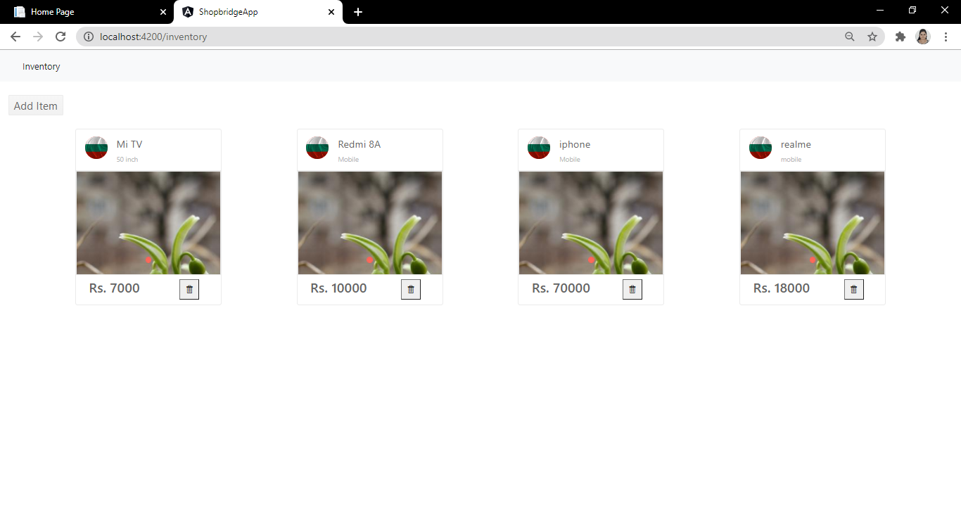

1. **Add Item page**

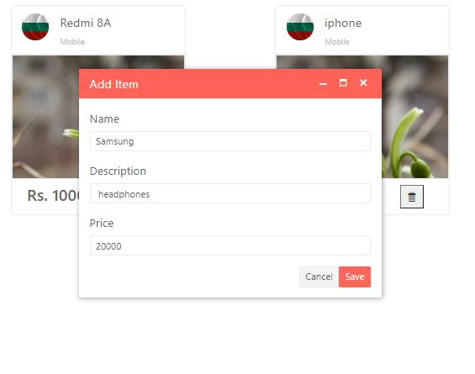

1. **Save Item Success**

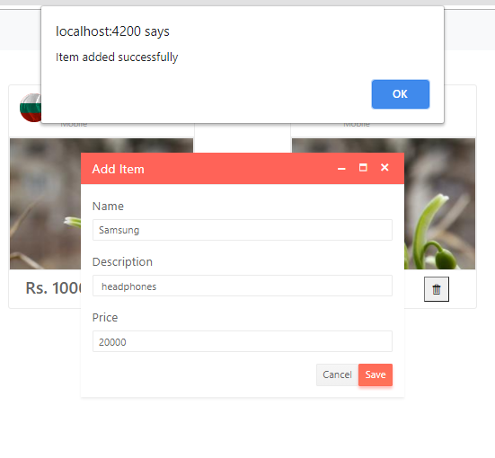

1. **Newly Added Item**

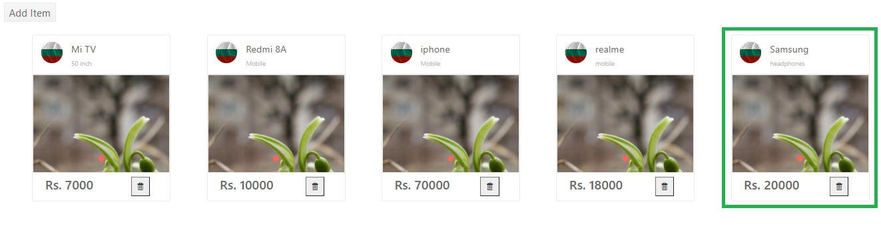

1. **Delete Item**

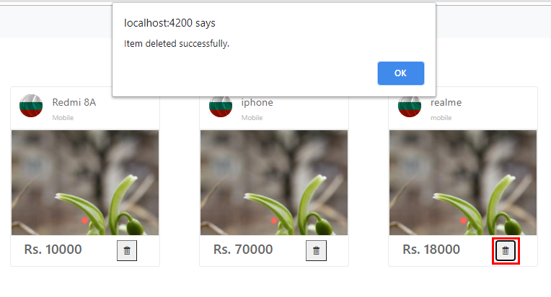

1. **Delete Item success**

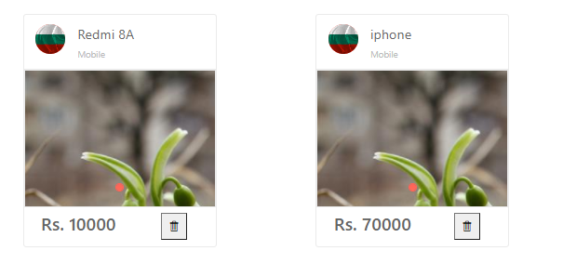

1. **Database**

